**Chapter 2 File**

This section enables you to record a new file (open file), find file, update of file details, approval of files, closure of files, update of file opening balance and change file type.

*In This Chapter:*

**2.1 Create New File**

**2.2 Manage File**

**2.3 Manage File Document**

**2.4 Close File**

**2.5 Undo Close File**

**2.1 Create New File**

This option enables you to create a new file. Moreover, the file must contain at least 1 client record and you cannot open a file without selecting P.I.C (Person in Charge), Department and File No. You can open a file while blank other than 3 of that, but it is not advisable.

* To open New File, on the **SmartLeg@l** navigation, click **File** and go to **New File Master** a create New File window will appear as below.

**New File Master – New File Wizard – General**

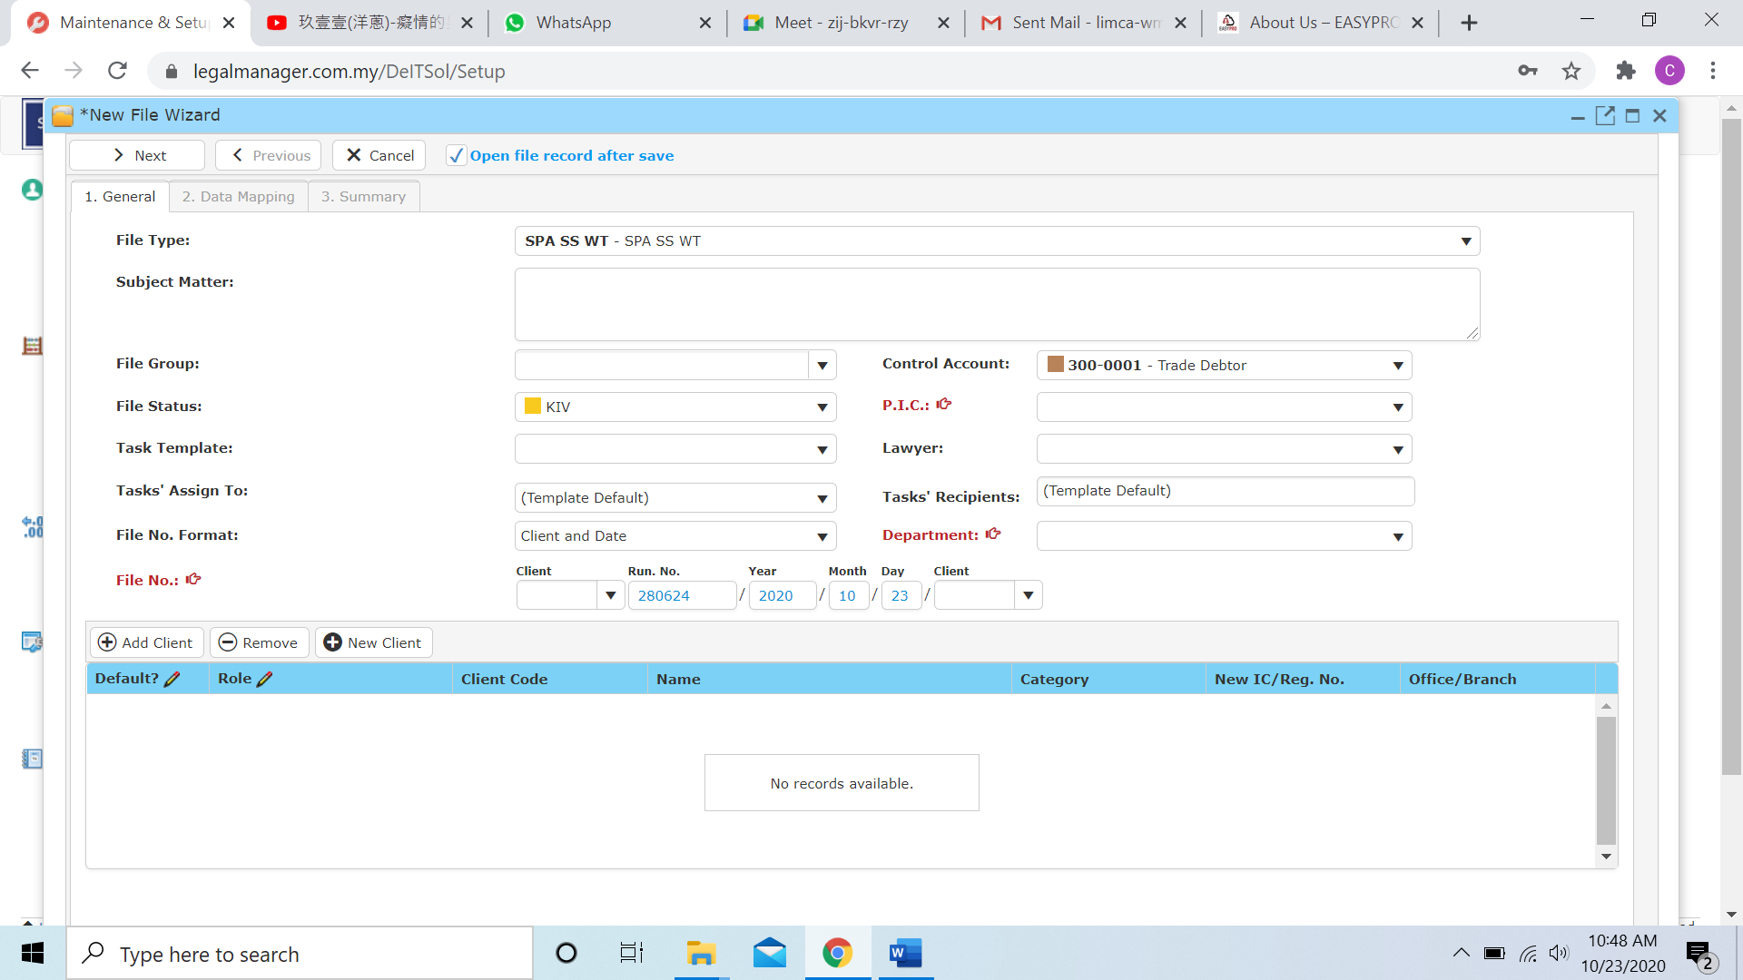

Figure: New File – General

1. Select a file type from combo box.
2. Enter the Subject Matter is advisable.
3. Select a file group.
4. Select file status from combo box
5. You may select a Task Template based on the selection provided as figure shown.

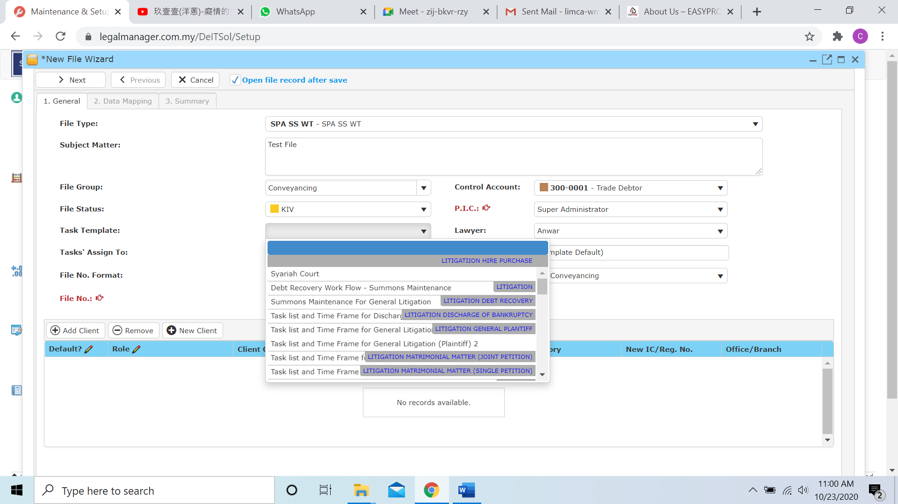

1. Task’s Assign to you can choose to assign who in the list

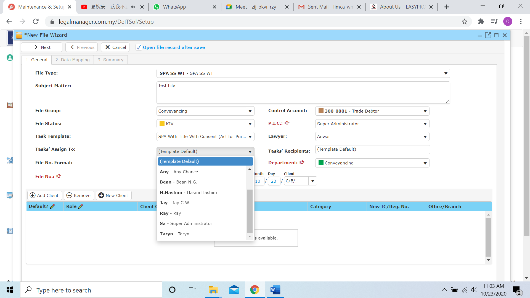

1. Select File No. Format to decide the File No.
2. Choose person in charge, as example below the person in charge is ‘sa’.

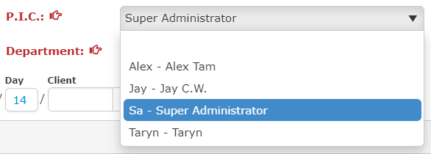

1. Add Client to the file at bottom, when you click ‘Add Client’ you can search your client as ‘Figure: New File – Add Client’ shown. If no Client click ‘New Client’ can create New Client as refer to Chapter 1 Client 1.1 New Client. Click ‘Remove’ to remove client from the client list.

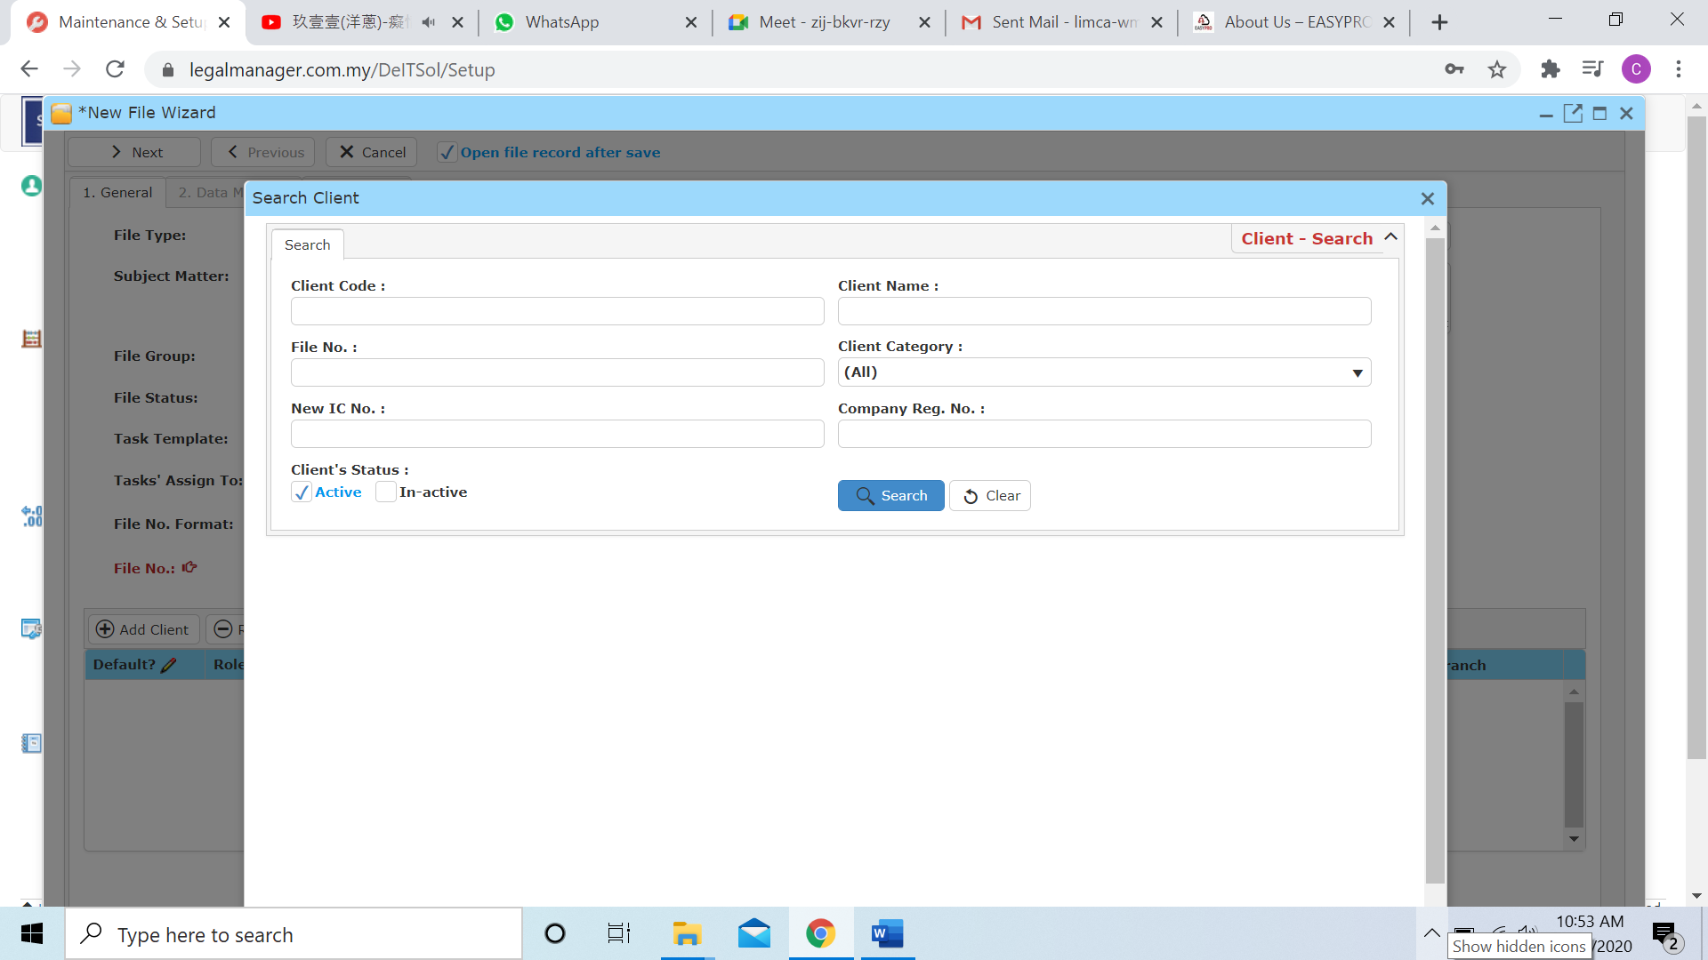

Figure: New File – Add Client

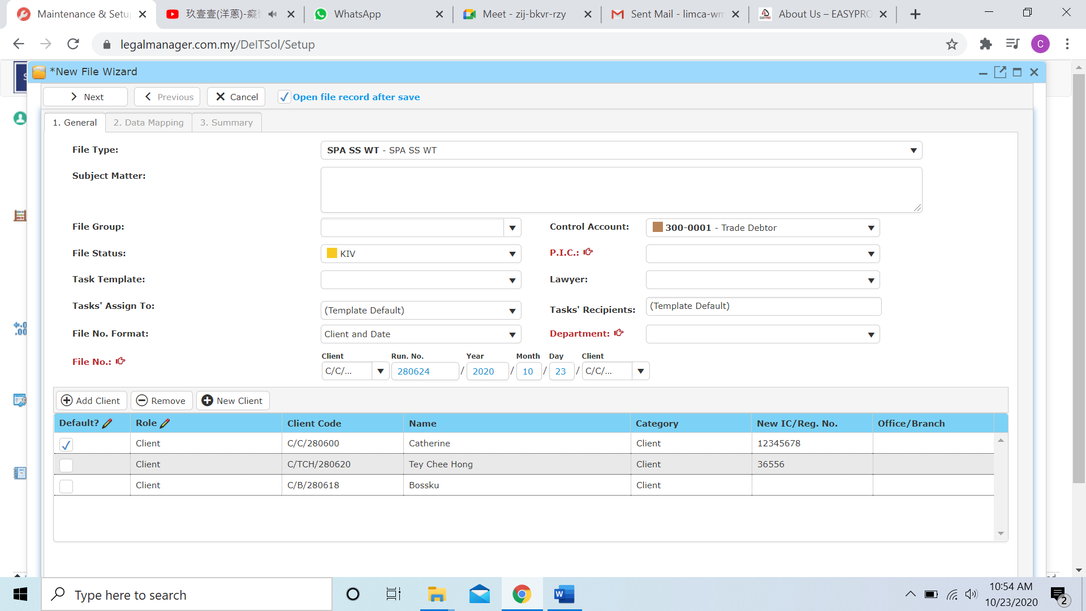

Figure: New File – Added Clients

Note: The client with the ‘**Default**’ tick, mail merge details like address will fill with the client with tick as default. For instance, ‘Figure: New File – Added Clients’, the **Default** tick Catherine as default so that the information will fill as Catherine’s details as default

**New File Master – New File Wizard – Data Mapping**

* The **Data Mapping** is mapping client’s character like borrower, vendor and other information mapping
* To make your life easier you can click ‘Auto-Mapping’ and click ‘Clear All Mapping’ to delete all the mapping made.
* You can change the **File Type** by click ‘**Previous**’ and go back to **General** to change it.
* In case of, because there may be multiple clients inside a file master, and different person playing a different role so that, data mapping is use to make to role playing more clearly. (For example, Catherine is a purchaser, then map the role of Catherine at purchaser, as well as Tey Chee Hong is a Vendor and ABC Company is a developer so that map them at their role)

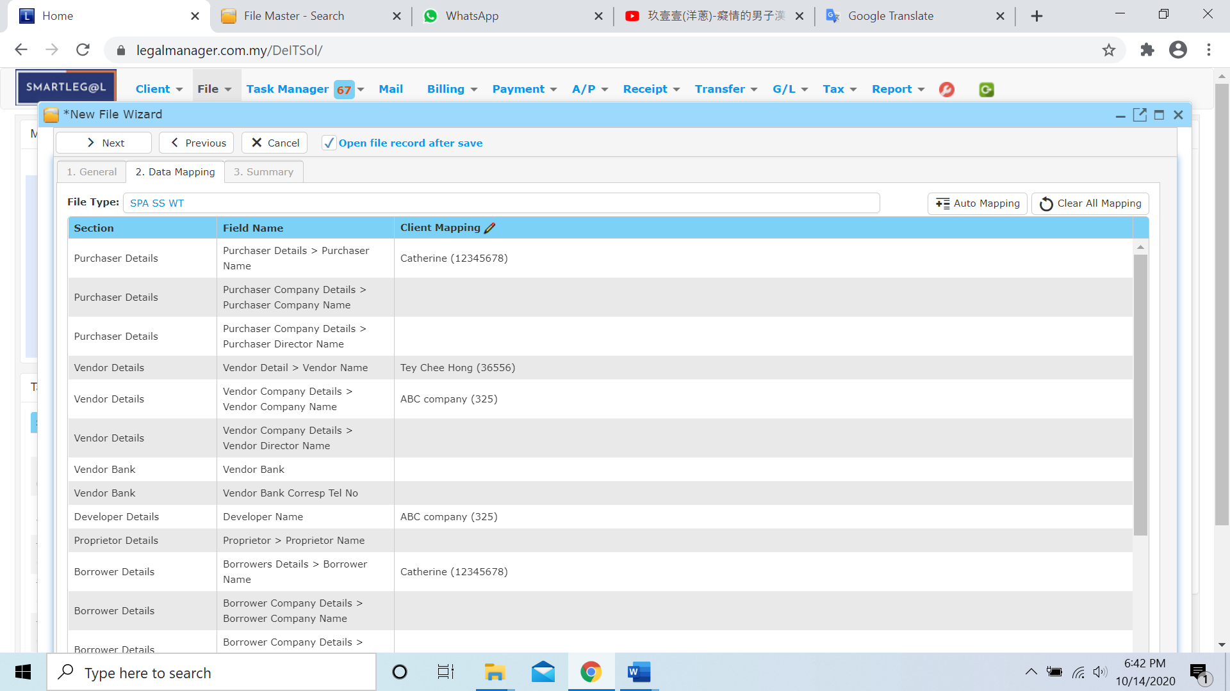

Figure: New File – Data Mapping

**New File Master – New File Wizard – Summary**

* After finish with the **General** and **Data Mapping** click ‘**Next**’ and it will go to generate a **Summary** about the New File you just created and click ‘**Save**’.

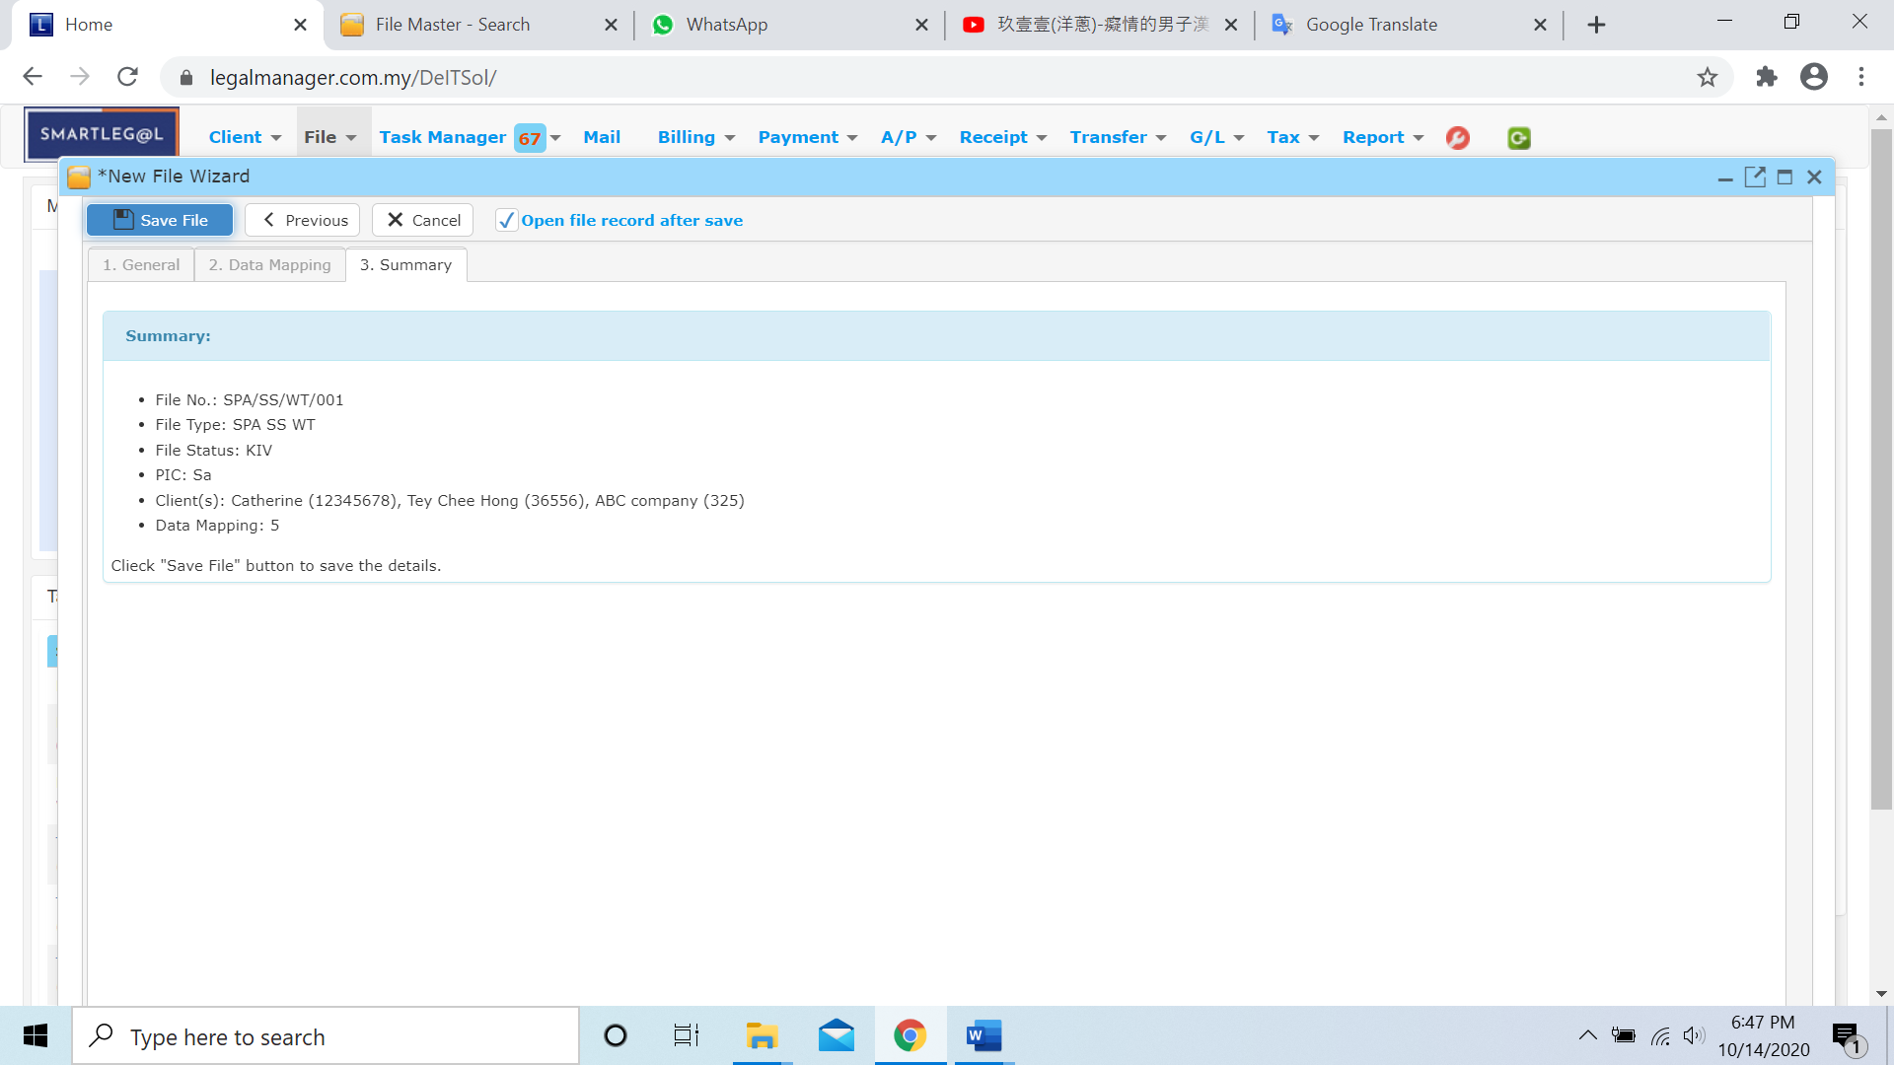

Figure: New File - Summary

**2.2 Manage File**

This option enables you to add, edit, and delete a file. It also allows you to keep track of file details and all related information.

* To open Manage File, on the **SmartLeg@l** navigation, click **File** and go to **Manage File** then search the file you wish to modify.

**Manage File**

* Search the file you wish to manage through type the search criteria or search by advanced.
* To start a new search or to clear the search results, click ‘**Clear**’.

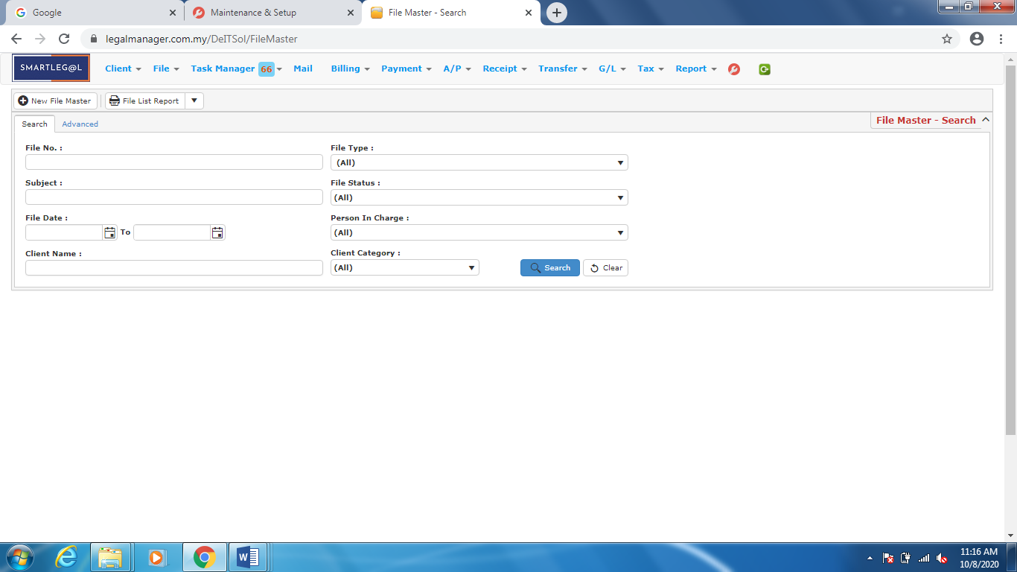

Figure: Manage File – Search

**Advanced Search File**

* This function can be used to find a file by searching other information that is not captured in the ‘General’ section.
* Define search criteria:

**- Field** - Choose the field you want to search.

**- Condition** - Search condition

**- Value** - Type in the detail you want to find.

* Click ‘**Add to list**’, to define more than one criteria.
* Click ‘**Find**’, search results will be displayed at search record list. You can open an item in the search results list by double-clicking.
* To start a new search or to clear the search results, click ‘**Clear**’.
* Click ‘**Export**’ to print the desired search results in txt, excel or html format.

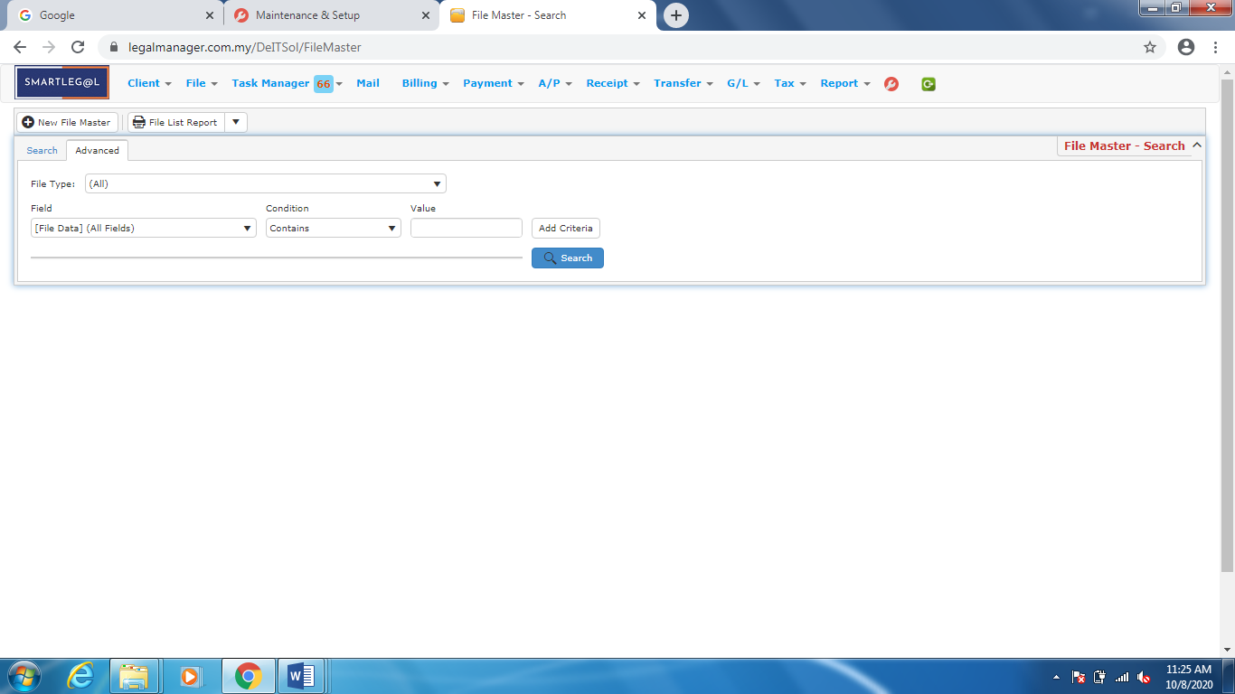

Figure: Manage File – Advanced

* For example, I add the file type, SPA SS WT in advanced search

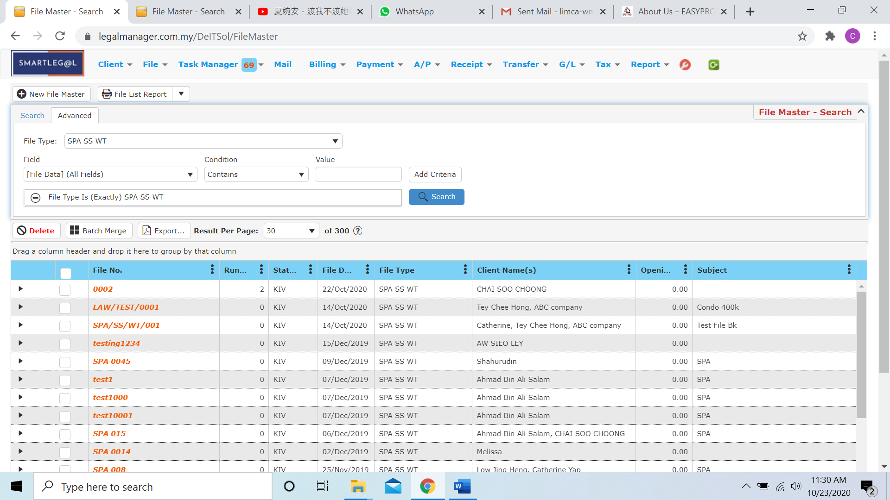

* It will appeal all file type with SPA SS WT
* Besides, I add more criteria like contain 004, then it shall shown the file type with SPA SS WT and contain 004

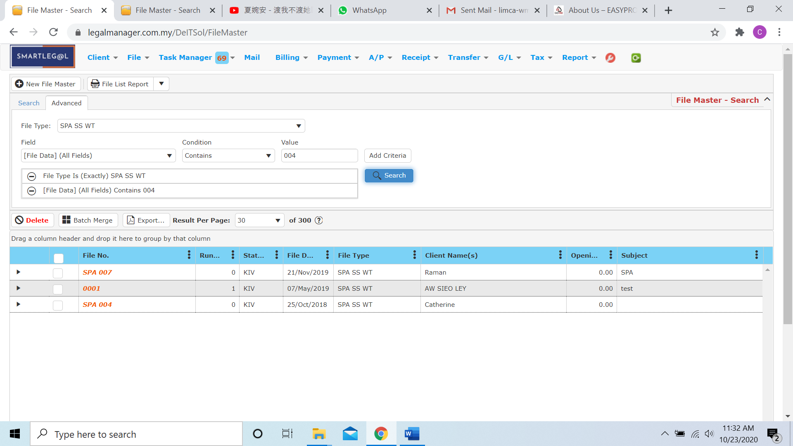

Note: You can straightly type the File No. to search the file

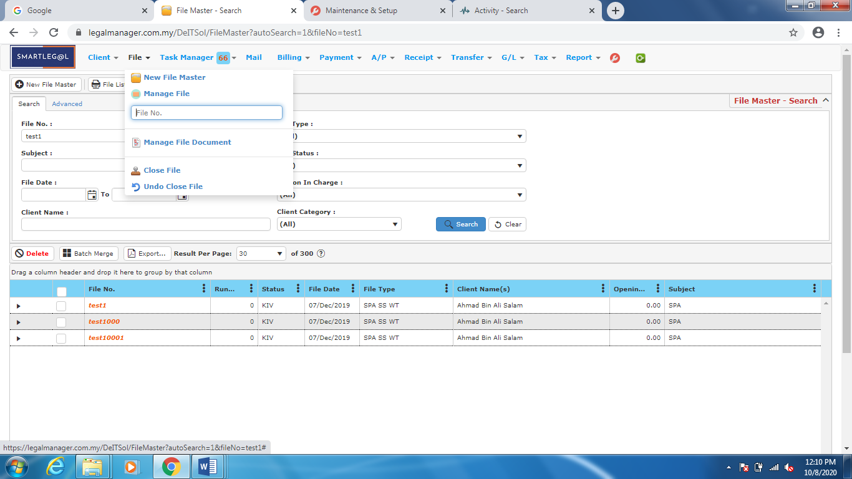

Figure: File – File No.

**Searched Result**

* Click ‘**Search**’ once, to show all Files
* The Searched result will appeal at below, otherwise it will shown no record availble if the file you searched do not exist.
* Click ‘**Delete**’ to delete the selected record.
* Click ‘**Export**’ to print the desired search results in txt, excel or html format.

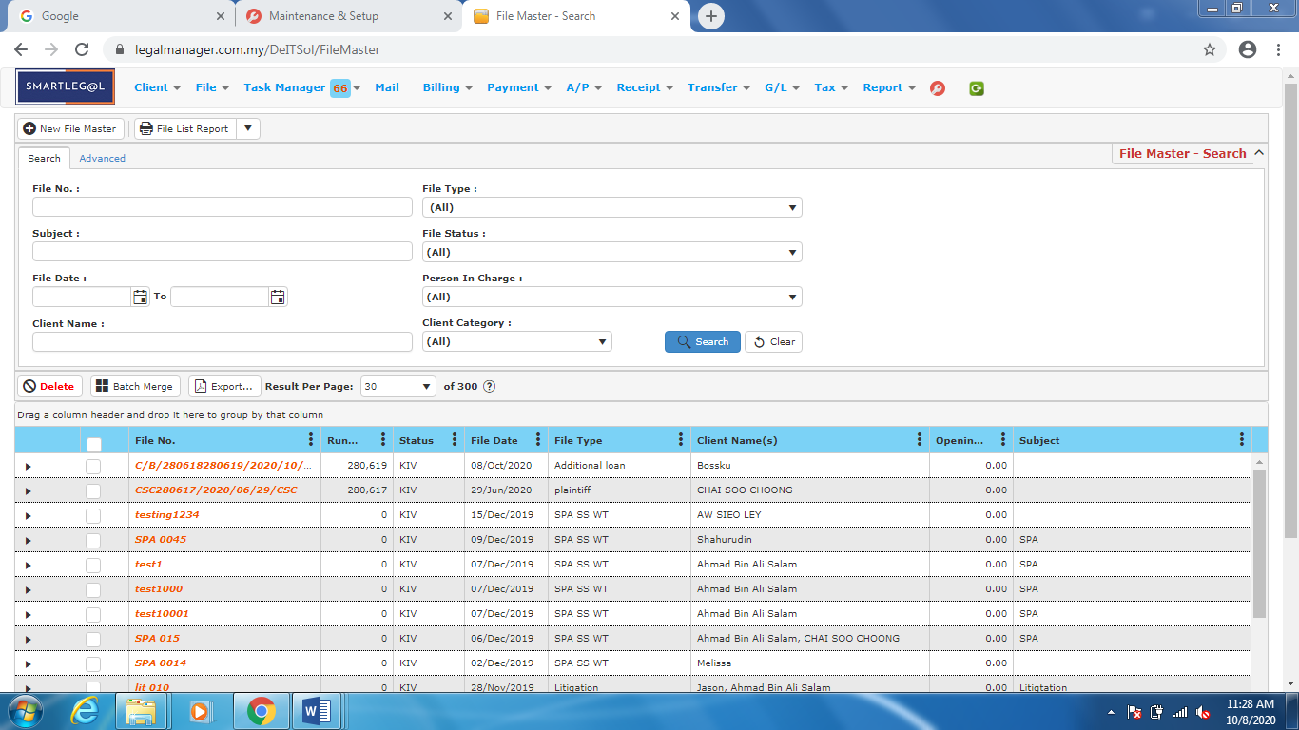

Figure: Manage File – Search All Files

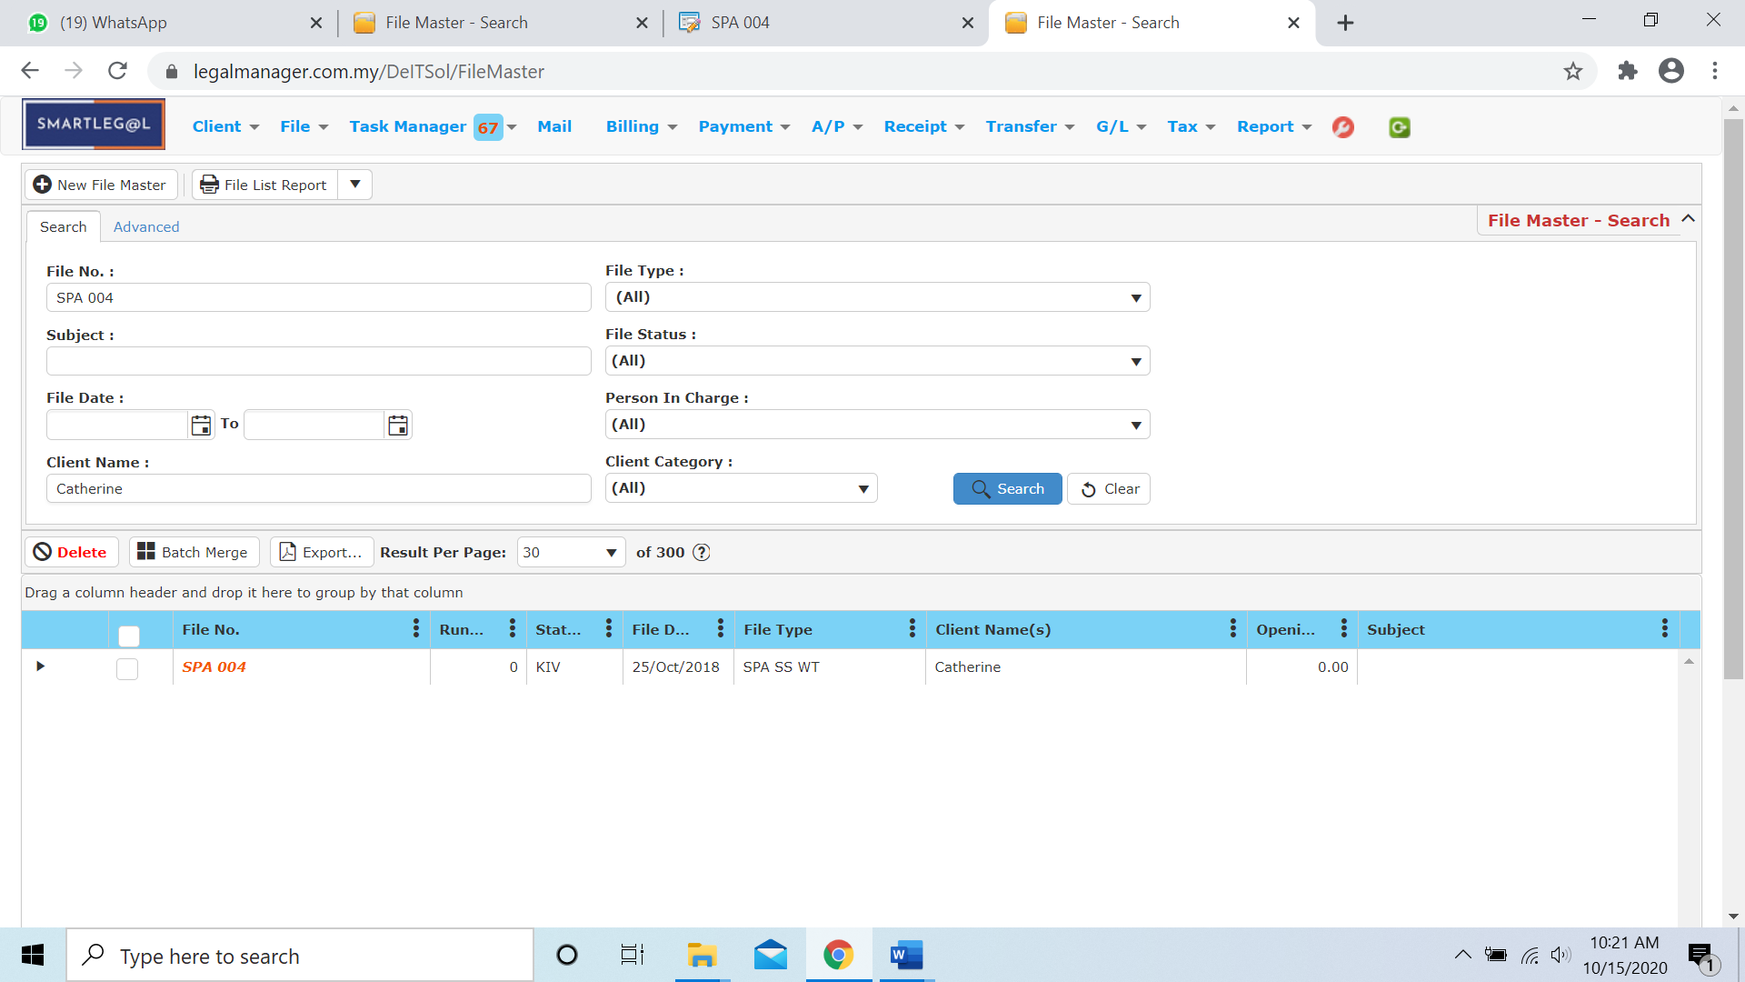

Figure: Manage File – Search Result

* After the file you searched appeal, you can choose to view and manage to edit those details by double-clicking the record.

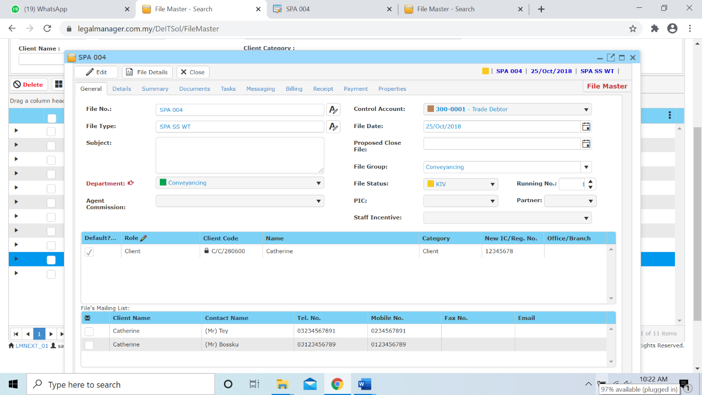  
Figure: Manage File – Search Result, File Info

**File Details**

* Click ‘**File Details**’ to fill in the required details.

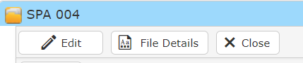

Fire: Manage File – File Details option

* The File Type must be defined by selecting the appropriate file type before you proceed

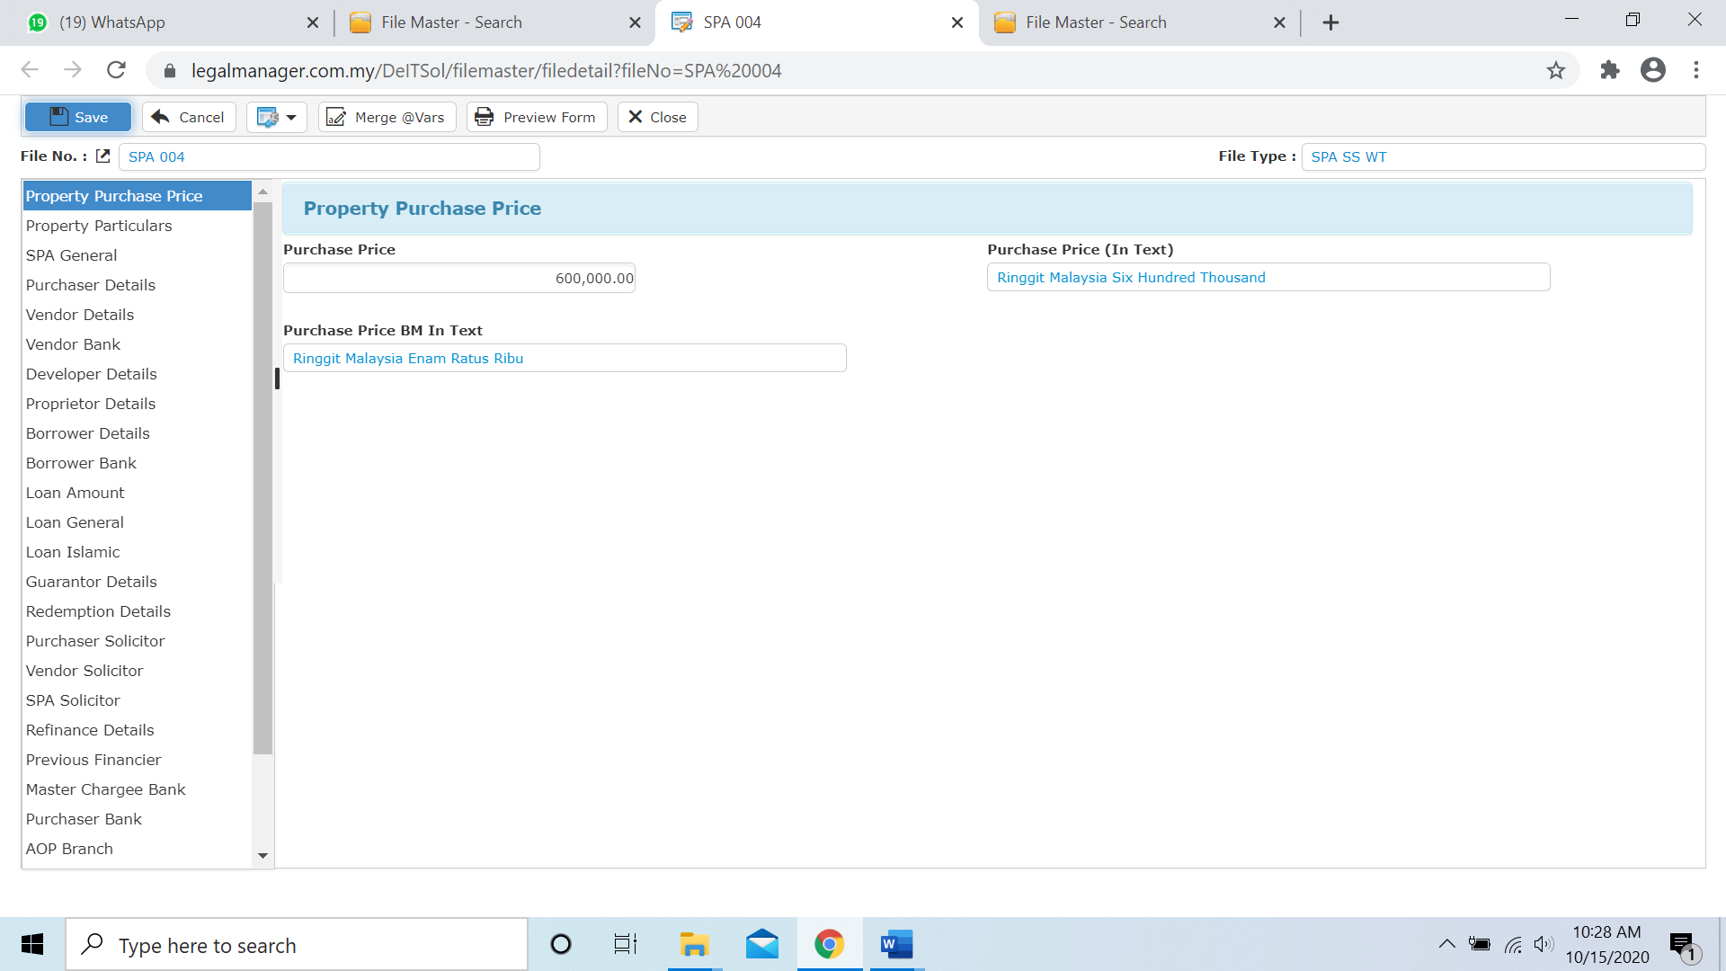

Figure: Manage File – File Details

* **Copy function** in file details
* When you click the icon at the navigation side, a selection menu as shown in ‘*Figure: Copy’* below will show up.



* This function allows you to:

a) Copy From: copy file details from another file.

b) Copy To: copy file details to another file.

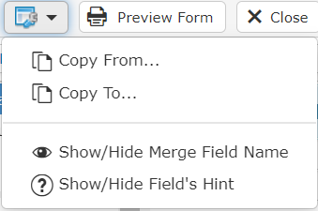

Figure: Manage File – Copy

Note: This function can only be used to files that are of the same file type.

**Copy From…**

* Select ‘**Copy From…**’ option. A **‘File Data Copy Wizard’** window will appear as shown below.

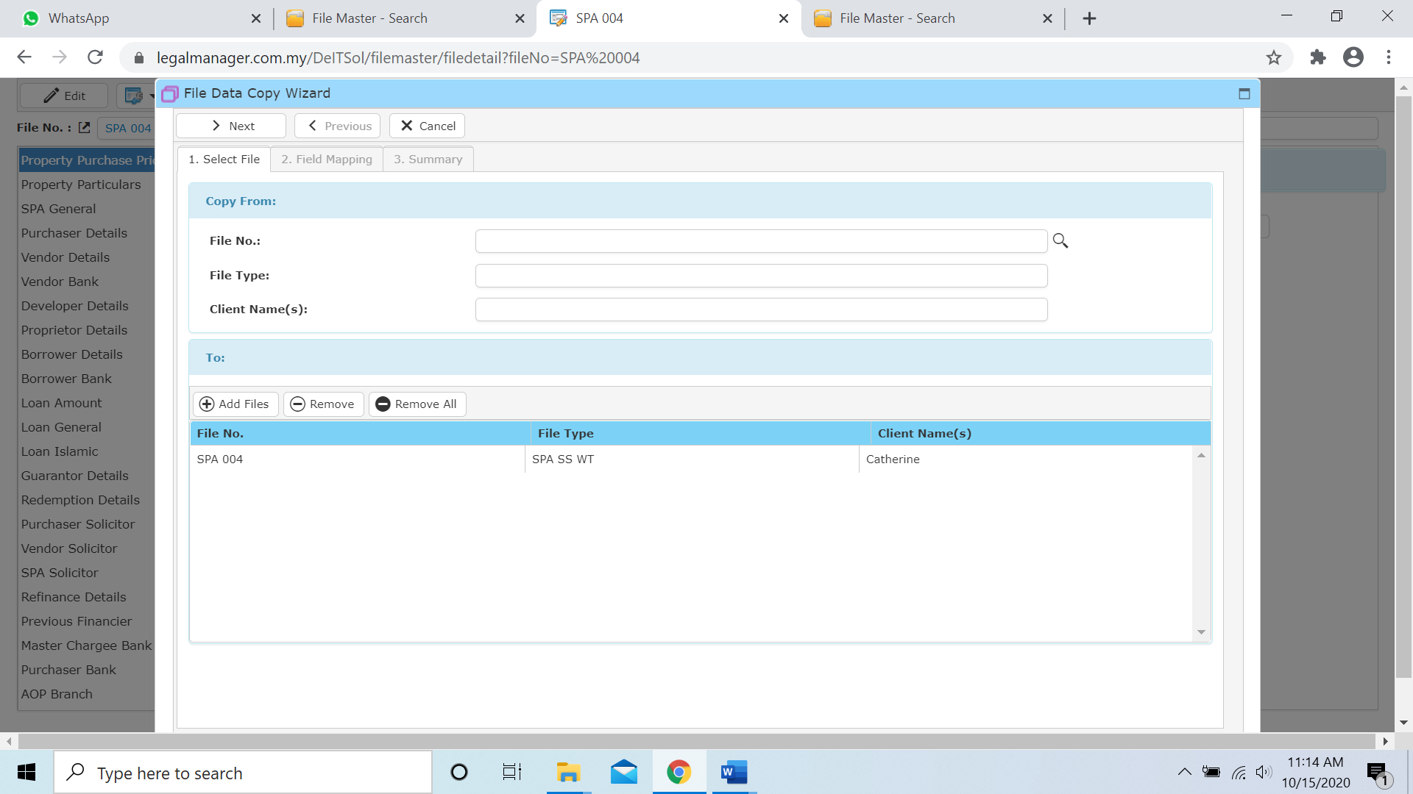

* click  to browse and select a file to copy from (e.g. SPA 004) and then double click.
* After that, ‘Add Files’ to copy from (e.g. SPA 004), for the To: (e.g. SPA/SS/WT/001)

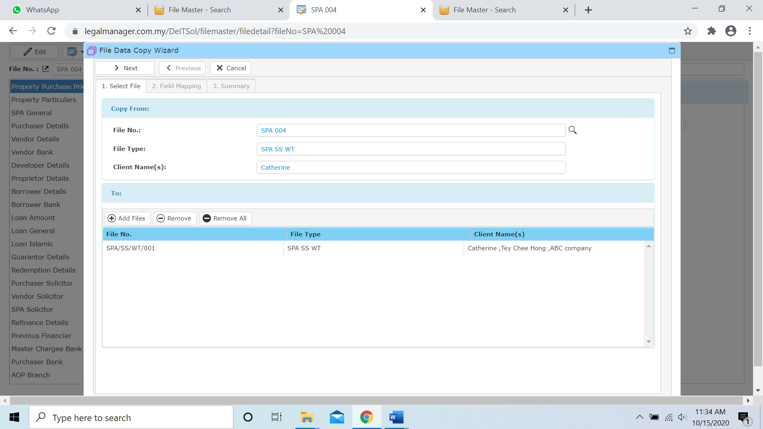

* Click ‘Next’ will go to Field Mapping
* To overwrite the existing file details by selecting ‘overwrite all if field data exist’

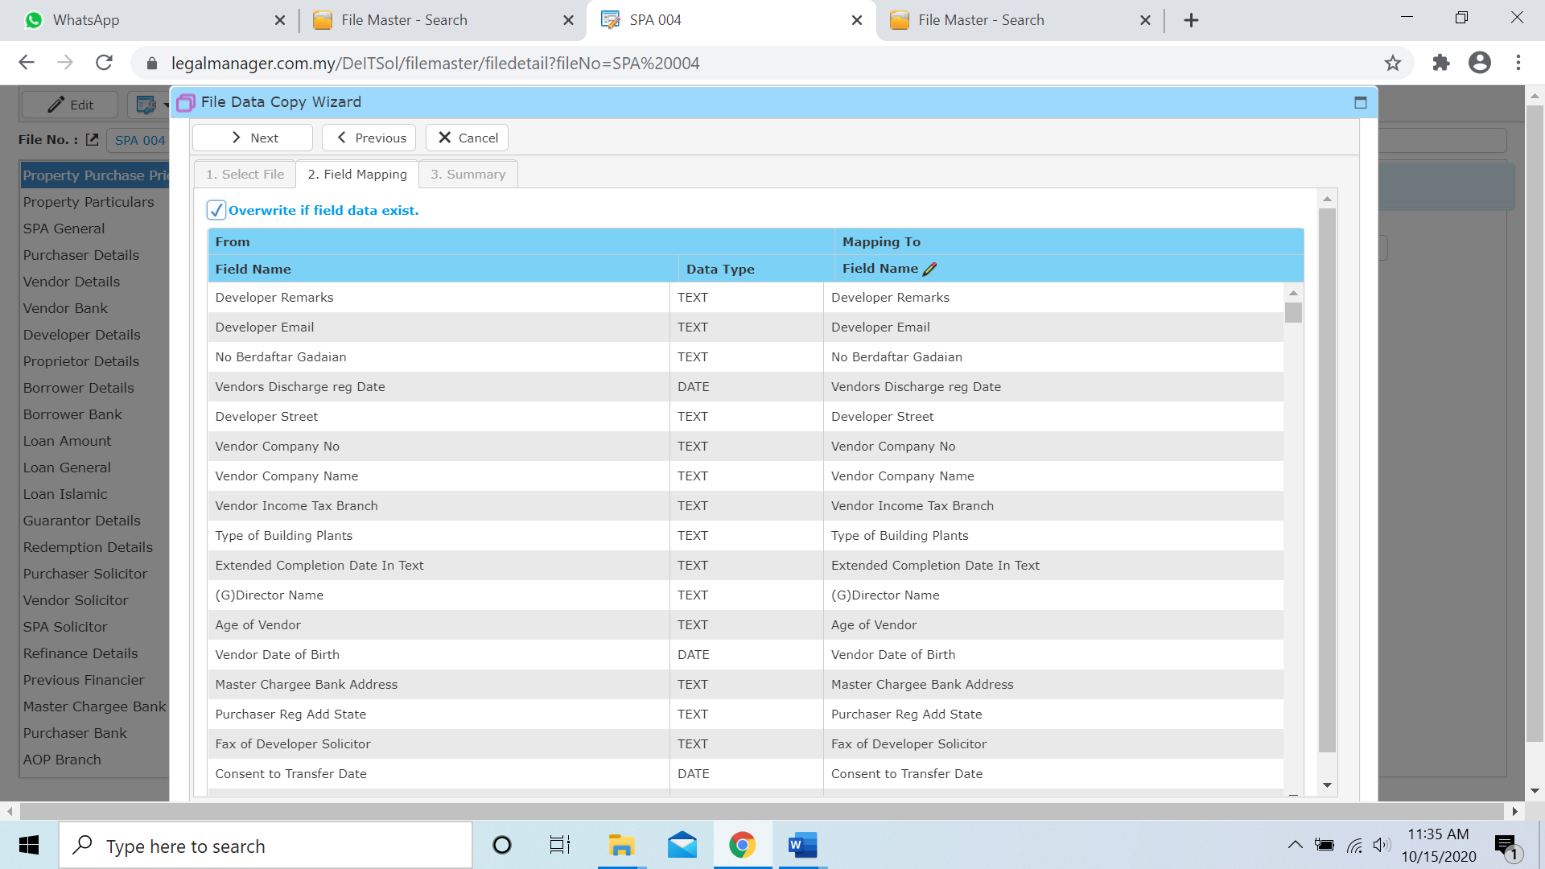

* Click ‘Next’ again then it will generate a summary

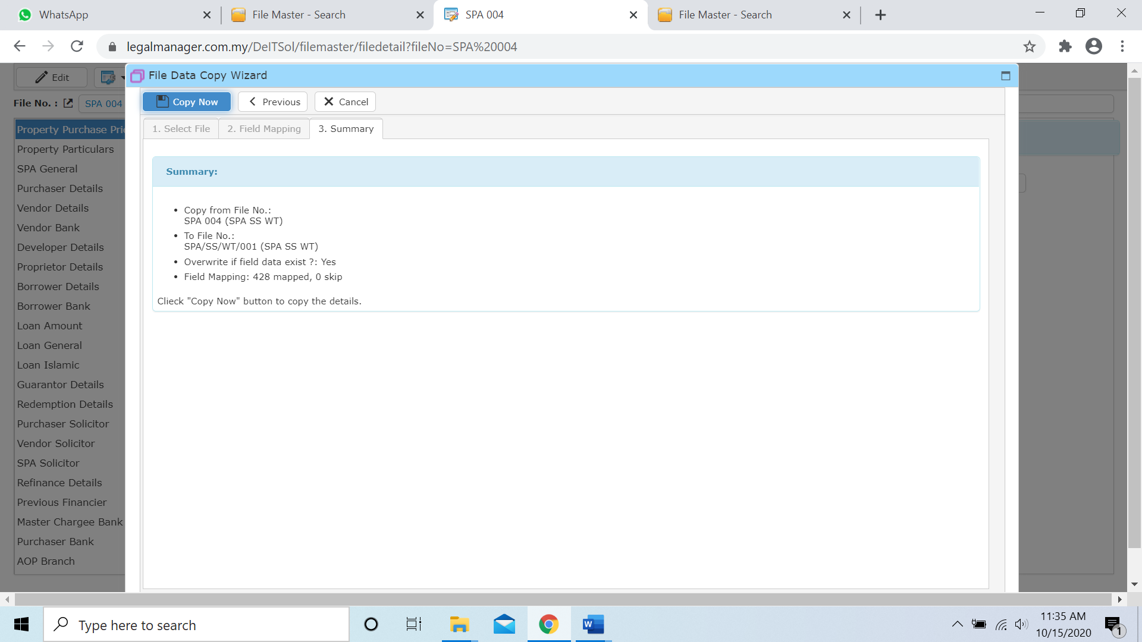

* Click ‘Copy Now’ to proceed the copy process

**Copy To…**

* Select ‘**Copy From…**’ option. A **‘File Data Copy Wizard’** window will appear as shown below.
* click  to browse and select a file to copy from (e.g. SPA 004) and then double click.
* After that, ‘Add Files’ to copy from (e.g. SPA 004), for the To: (e.g. LAW/TEST/0001)

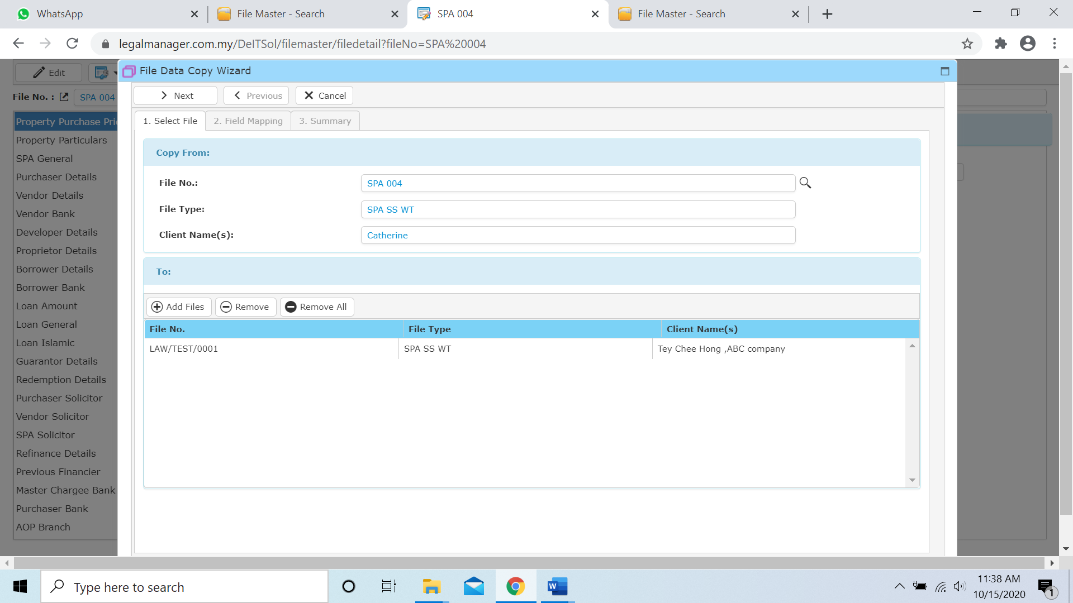

* Click ‘Next’ will go to Field Mapping
* To overwrite the existing file details by selecting ‘overwrite all if field data exist’

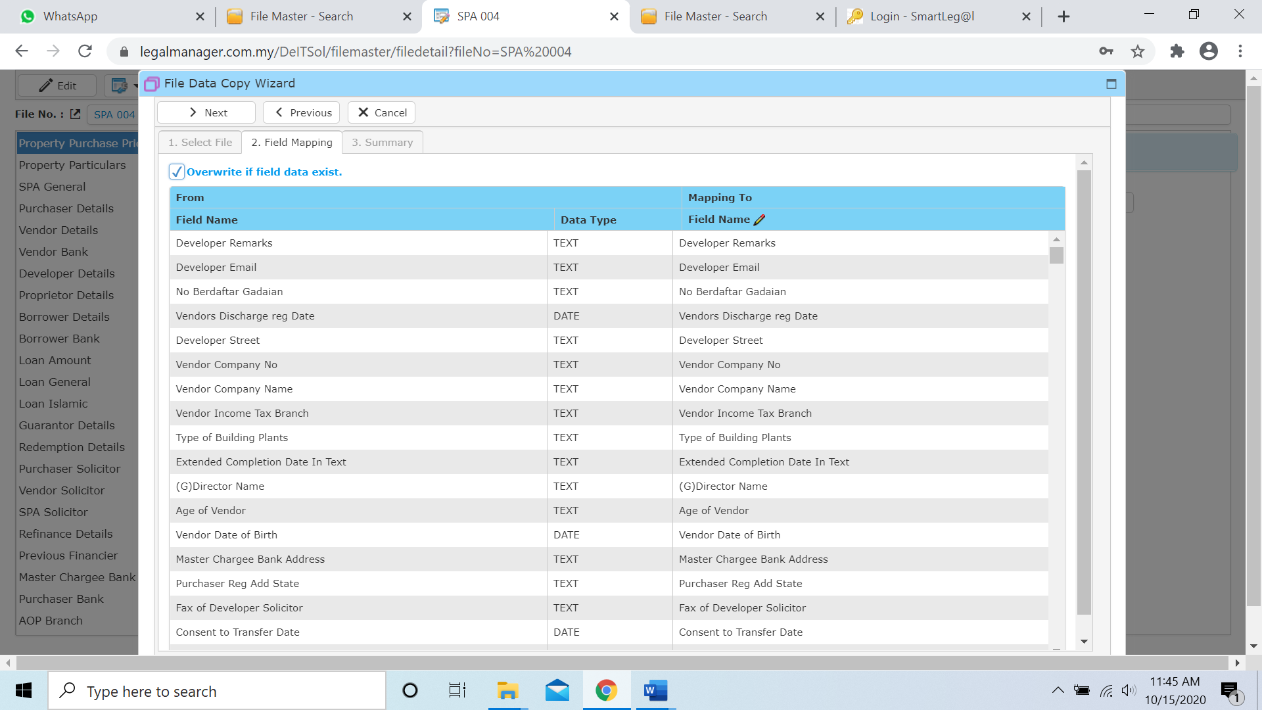

* Click ‘Next’ again then it will generate a summary

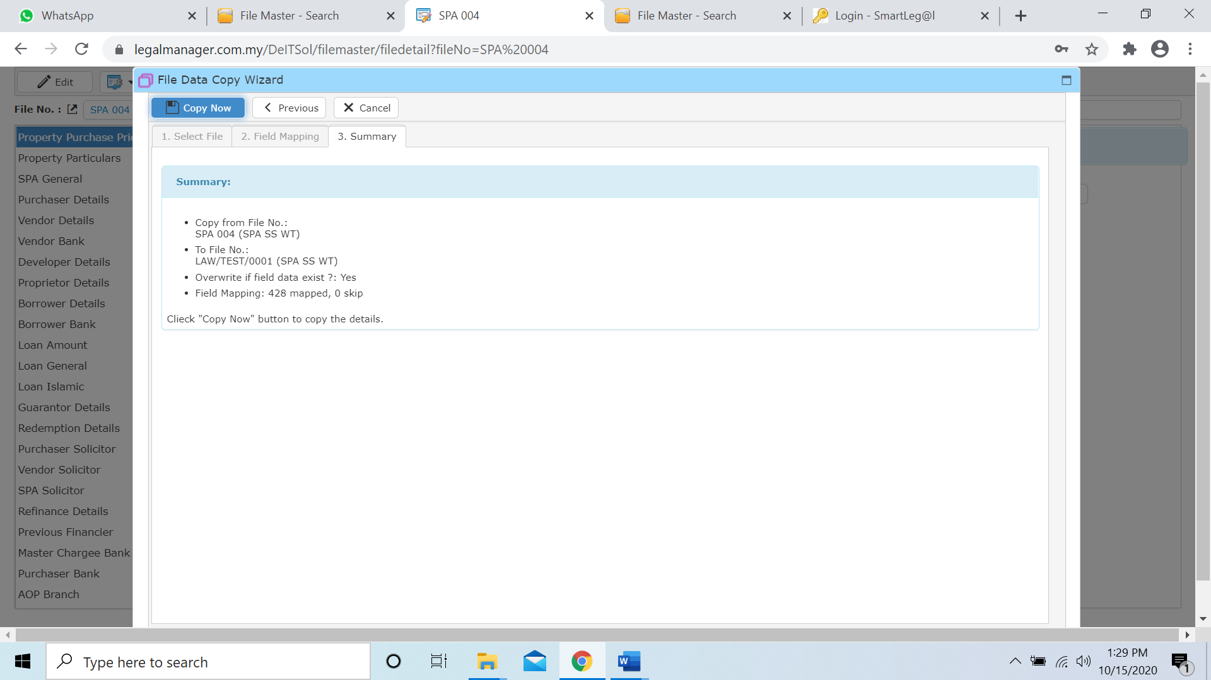

* Click ‘Copy Now’ to proceed the copy process

**2.3 Manage File Document**

This option enables you to add, edit, and delete a document. It also allows you to keep track of document details and all related information.

* To open Manage File Document, on the **SmartLeg@l** navigation, click **File** and go to **Manage File Document** then search the document you wish to modify.

**Manage File Document**

* Search the document you wish to manage through type the search criteria or search by advanced.
* To start a new search or to clear the search results, click ‘**Clear**’.

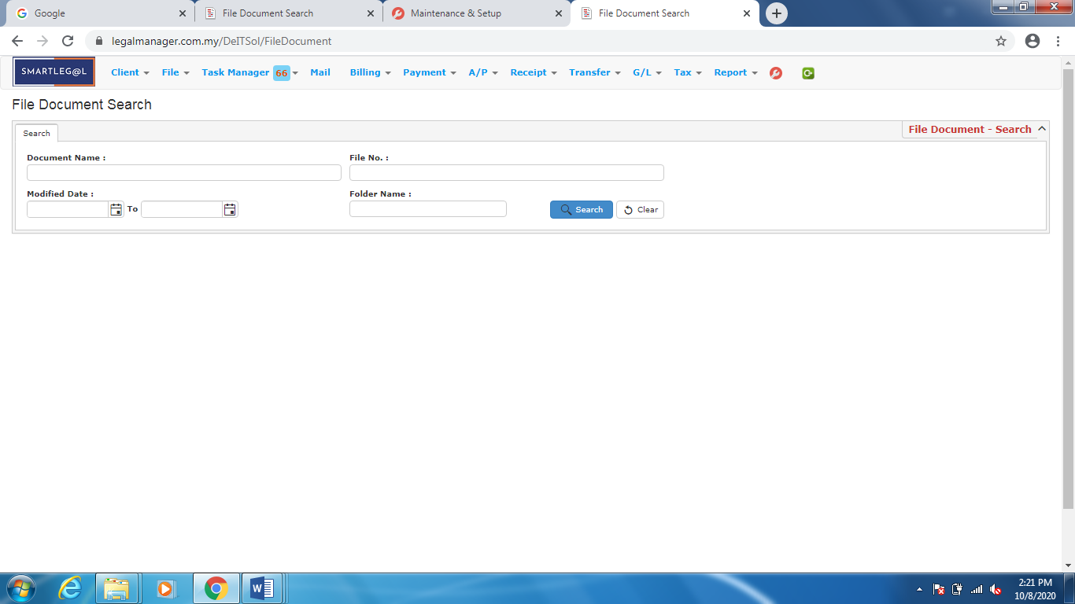

Figure: Manage File Document

* Other than typing those Document Name and File No. **Modified Date** allow you to select the start date from calendar to the period you wish to view. And all the documents in between the date you selected will appeal

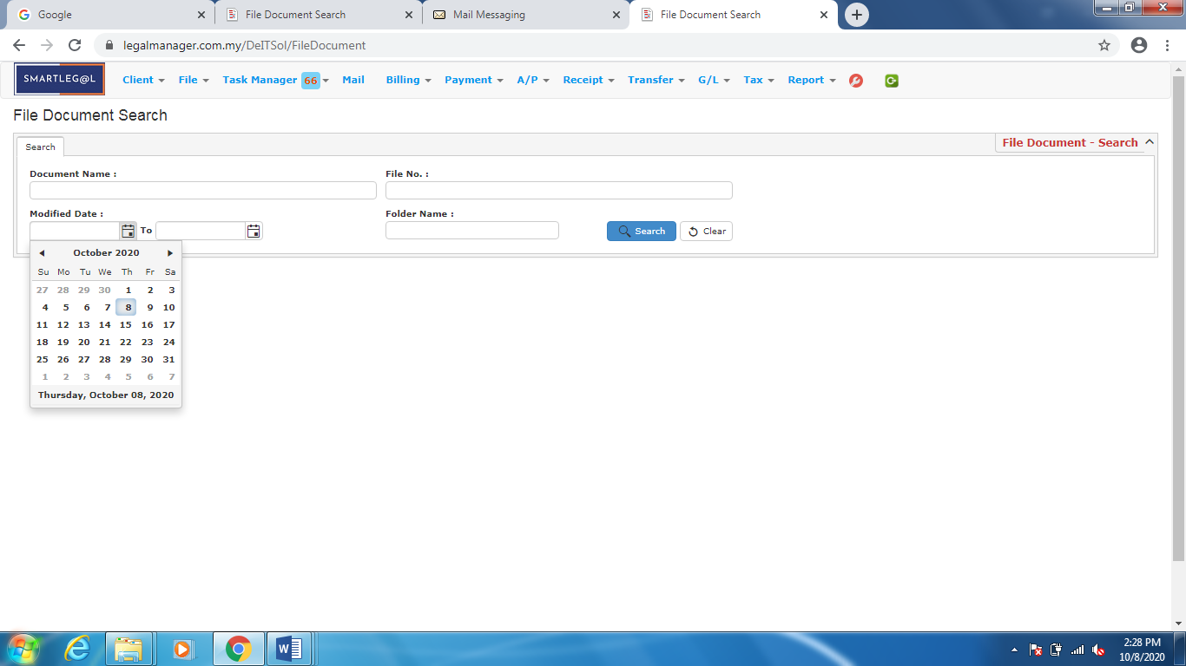

Figure: Manage File Document – Search with Modified Date

**Searched Result**

* Click ‘**Search**’ once, to show all Documents
* The Searched result will appeal at below, otherwise it will shown no record availble if the client you searched do not exist.
* Click ‘**Delete**’ to delete the selected record.
* Click ‘**Export**’ to print the desired search results in txt, excel or html format.
* Click ‘**Download(Zip)**’ to download the zipped document.

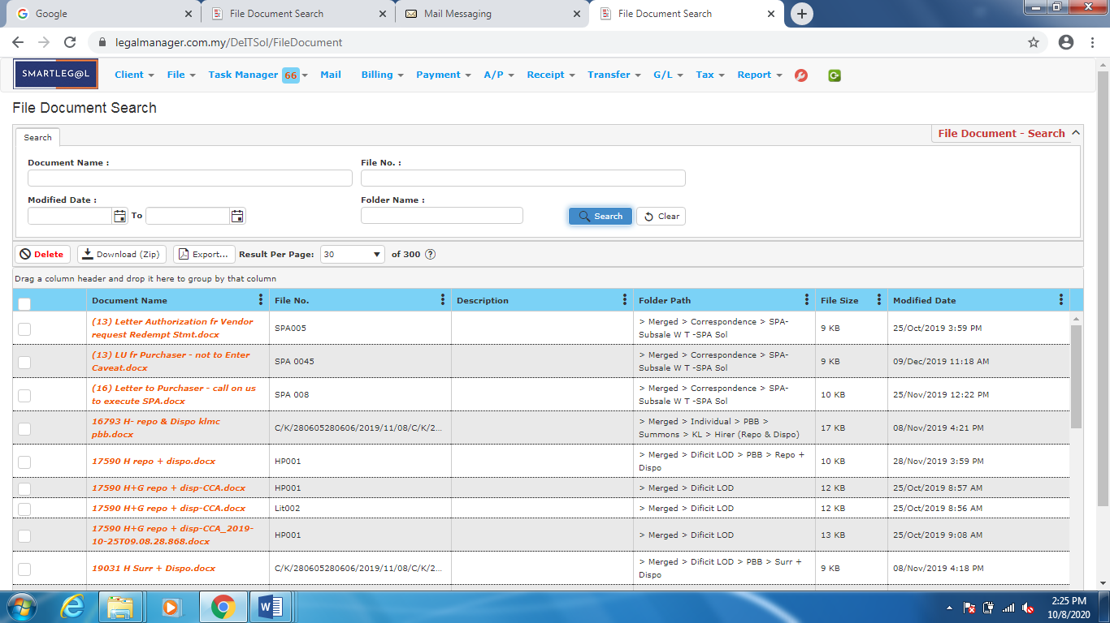

Figure: Manage File Document - Search All Document

* After the document you searched appeal, you can choose to edit, open with edittor to edit the content and download the document.

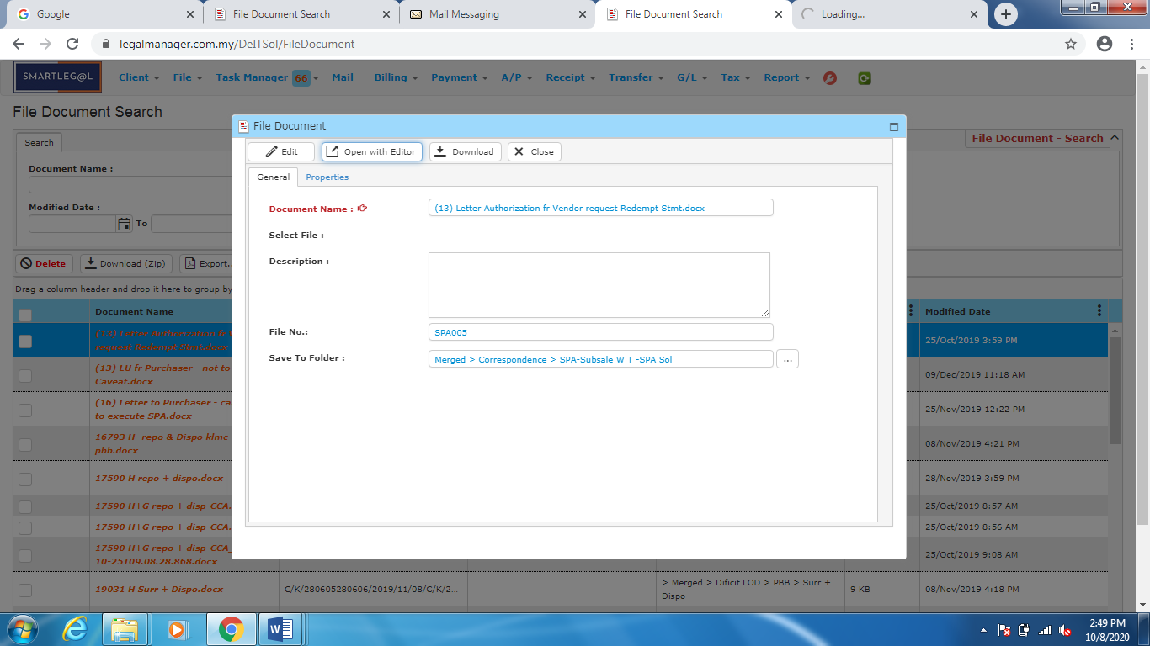

Figure: Manage File Document – Search Result, Document Info

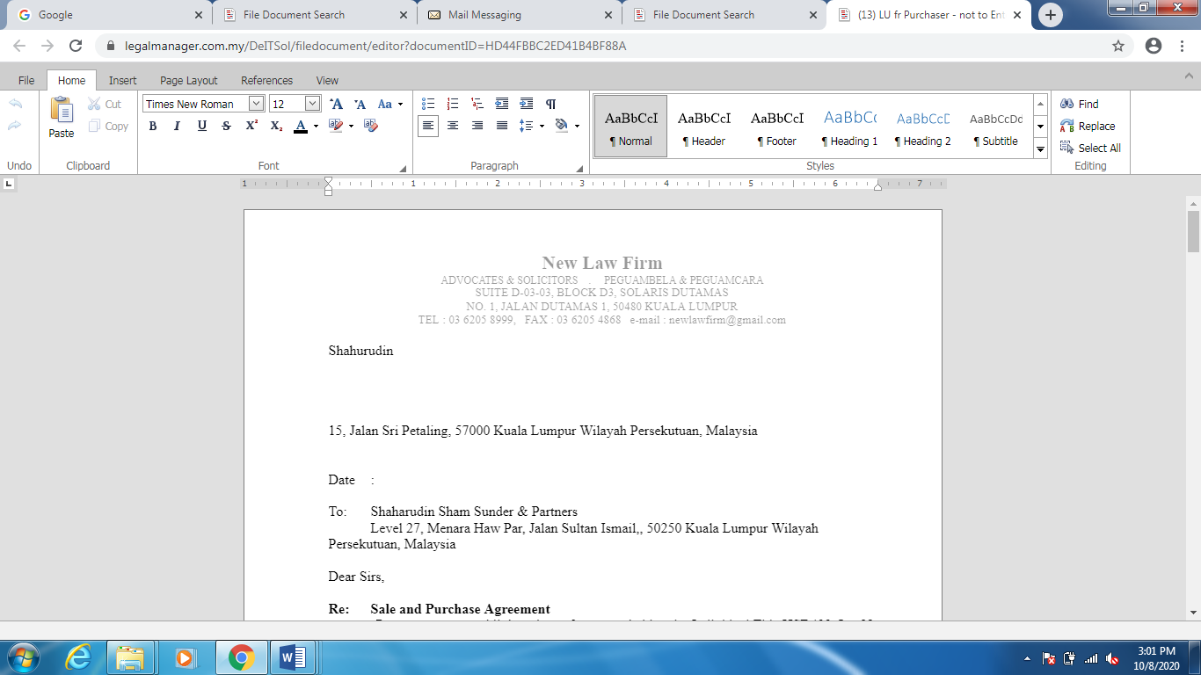

Figure: Manage File Document – Search Result, Document Info – Open with Editor

**2.4 Close File**

This option enables you to close a file. System will show all unclosed files by default.

* To open Close File, on the **SmartLeg@l** navigation, click **File** and go to **Close File** then search the file you wish to close.

**Close File**

* Search the document you wish to manage through type the search criteria
* To start a new search or to clear the search results, click ‘**Clear**’.

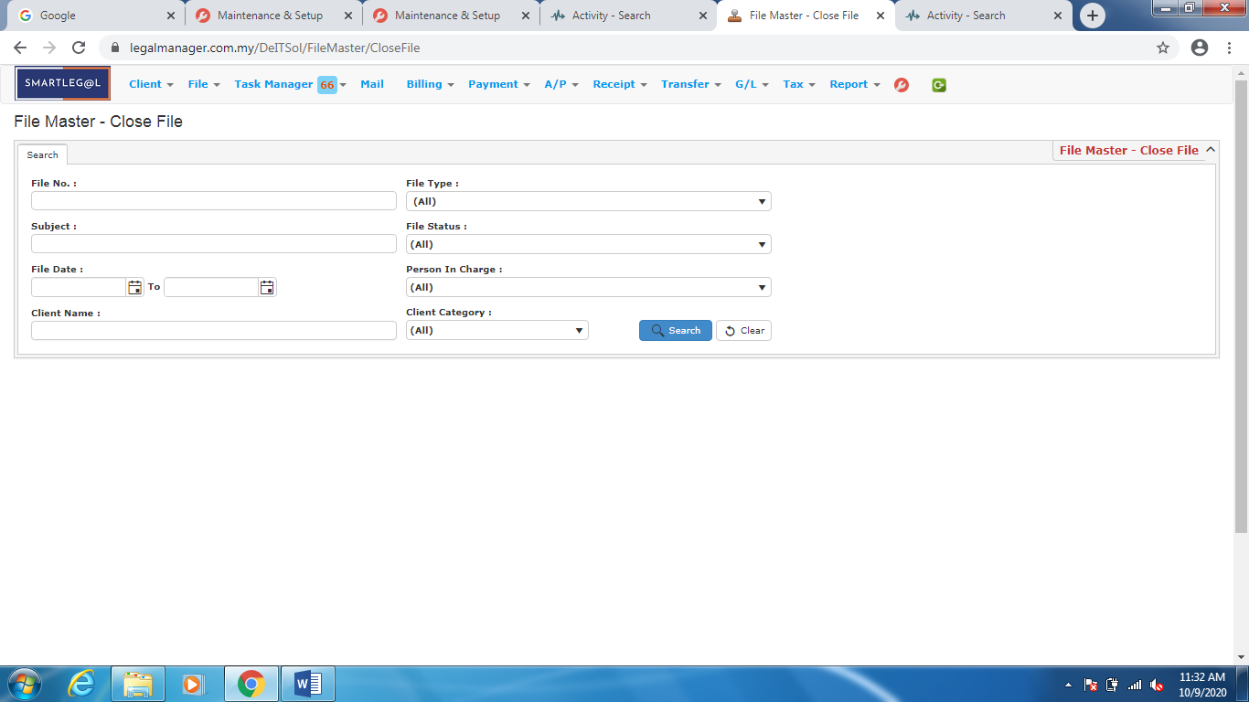

Figure: Close File

**Searched Result**

* Click ‘**Search**’ once, to show all Files
* The Searched result will appeal at below, otherwise it will shown no record availble if the client you searched do not exist.
* Select the check box beside the selected file no.
* For batch processing, tick the columnbeside File No.
* System will take today’s date as closing date. If your closing date is not today’s date, you can select a ‘**File Close Date**’.
* Click ‘**Close File**’.
* Click ‘**Export**’ to print the desired search results in txt, excel or html format.
* Click ‘**Delete**’ to delete the selected record.

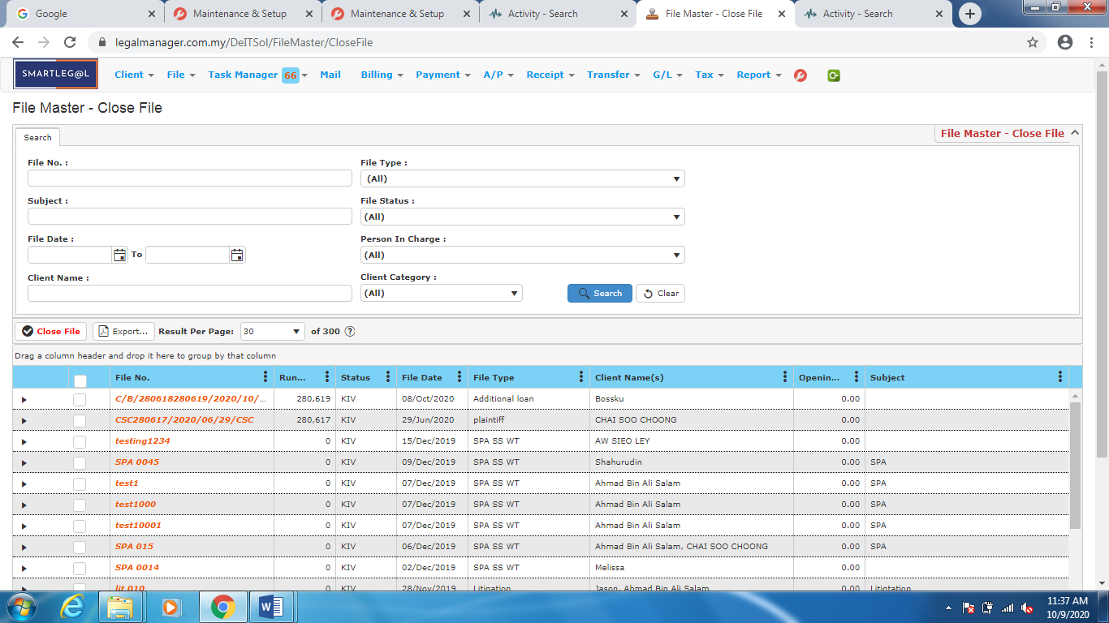

Figure: Close File – All Search

* After you selected the file you wish to close file, system will pop up and prompt a confirmation before you close the file.

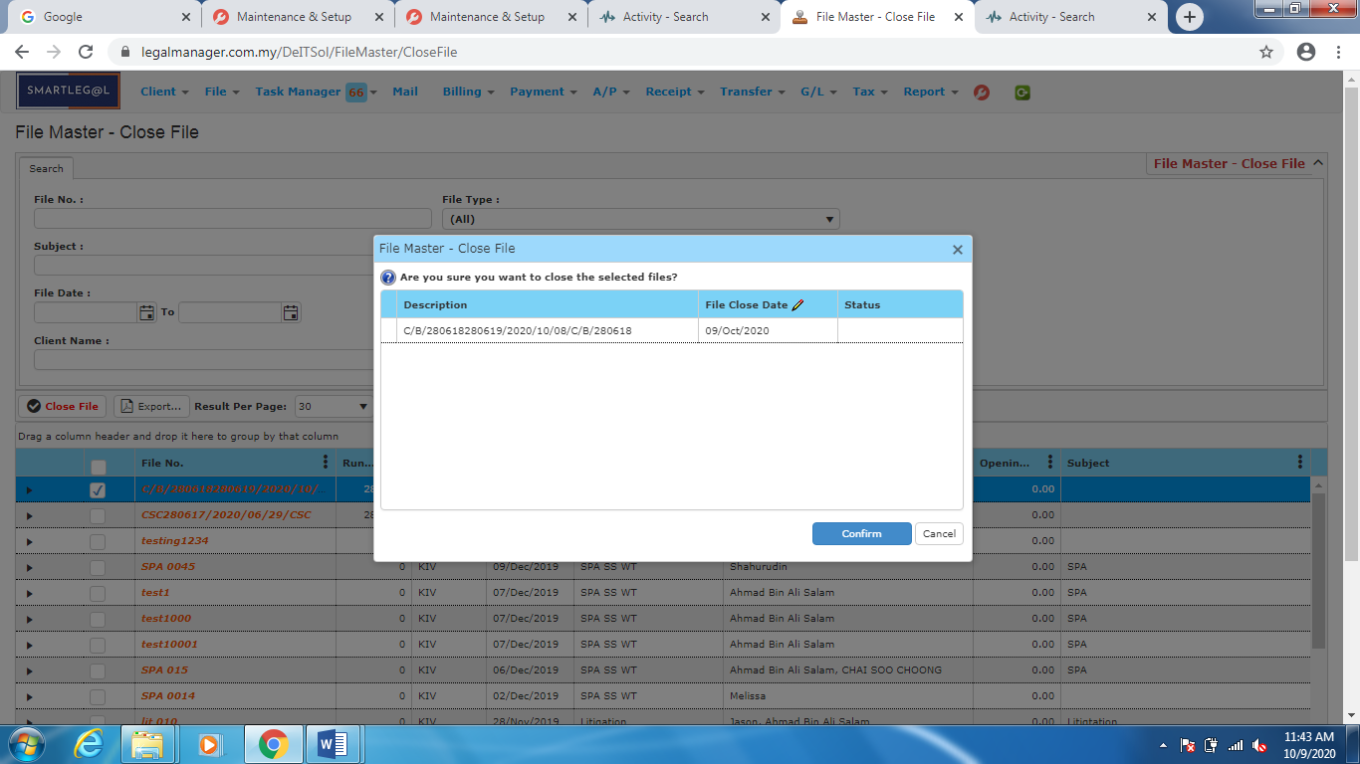

Figure: Close File – Confirmation

* After you confirm to close the selected file, the pop up confirmation you show a green tick beside the file you closed to show that you successfully closed the file.

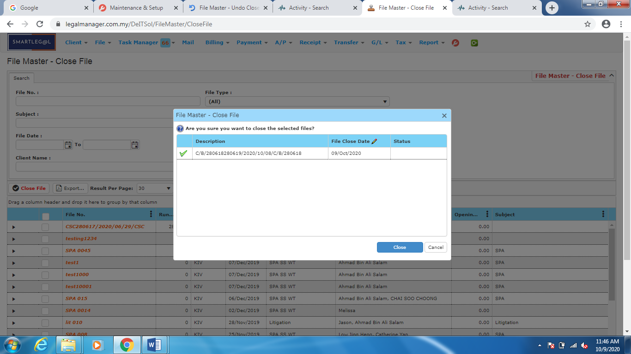

Figure: Close File – Successfully Close File

**2.5 Undo Close File**

This option enables you to undo close a file.

* To open Undo Close File, on the **SmartLeg@l** navigation, click **File** and go to **Undo Close File** then search the file you wish to close.

**Undo Close File**

* Search the document you wish to manage through type the search criteria
* To start a new search or to clear the search results, click ‘**Clear**’.

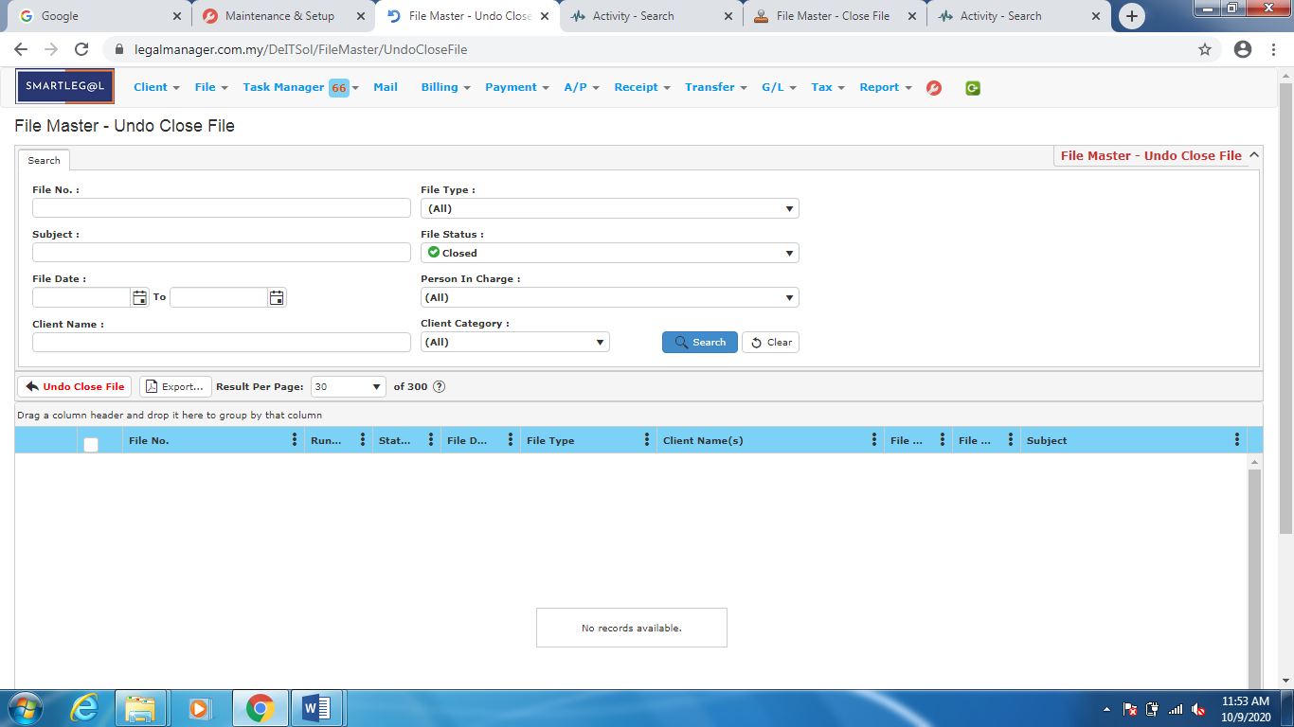

Figure: Undo Close File

**Searched Result**

* Click ‘**Search**’ once, to show all Files
* The Searched result will appeal at below, otherwise it will shown no record availble if the client you searched do not exist.
* Select the check box beside the selected file no.
* For batch processing, tick the columnbeside File No.
* Click ‘**Undo Close File**’.
* Click ‘**Export**’ to print the desired search results in txt, excel or html format.
* Click ‘**Delete**’ to delete the selected record.

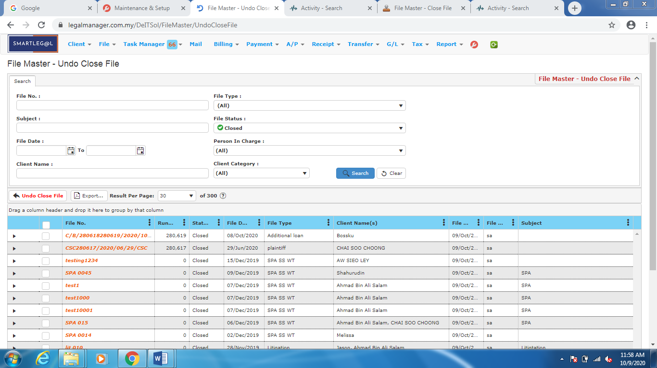

Figure: Undo Close File – All Search

* After you selected the file you wish to undo close file, system will pop up and prompt a confirmation before you unclose the file.

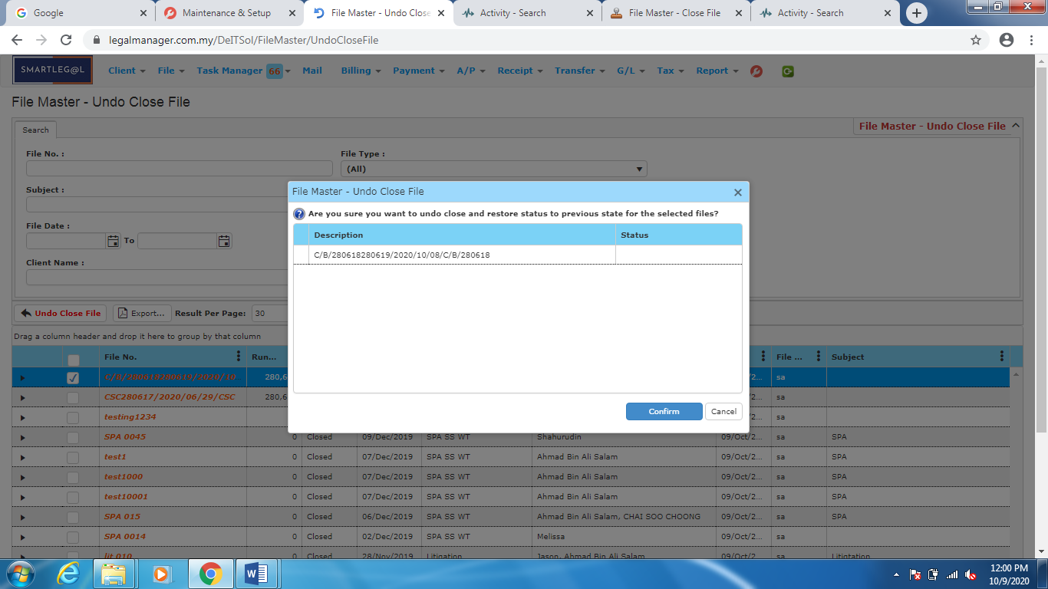

Figure: Undo Close File – Confirmation

* After you confirm to unclose the selected file, the pop up confirmation you show a green tick beside the file you closed to show that you successfully undo close the closed file.

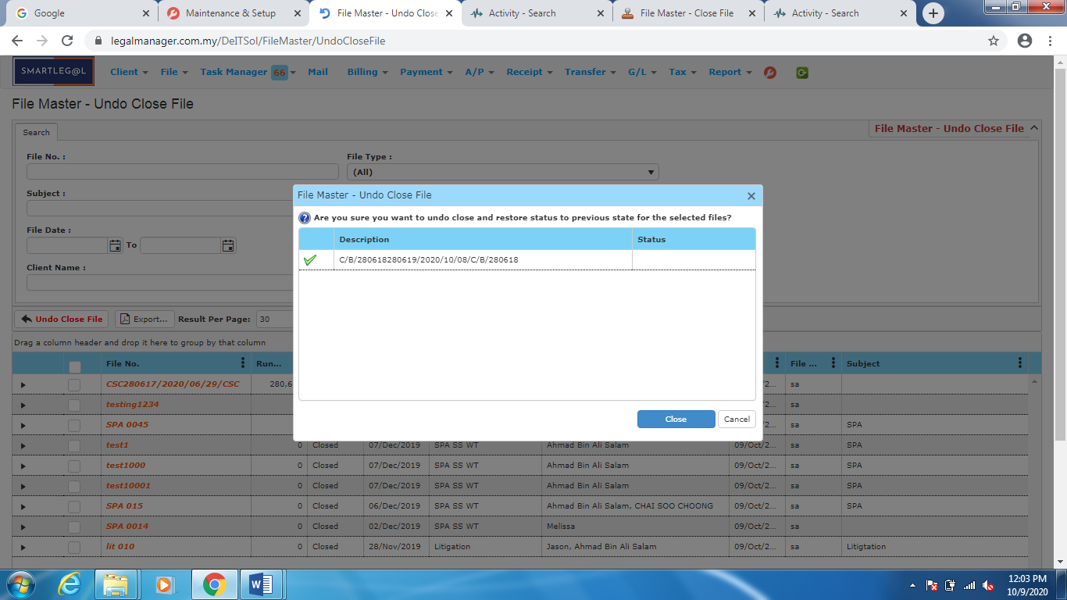

Figure: Undo Close File – Successfully Undo Close File